**Import data to MongoDB**

**Installing Database Tools**

**Step 1:** To use mongoimport tool we have to first download the MongoDB database tools .zip file from [**https://www.mongodb.com/try/download/database-tools**](https://www.mongodb.com/try/download/database-tools)

**Step 2:** After downloading the zip file and unzip the downloaded folder.

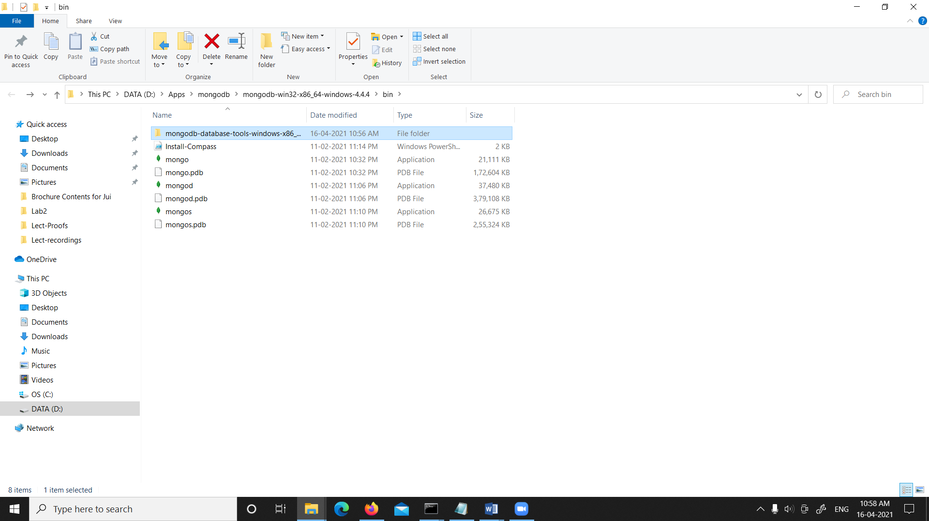

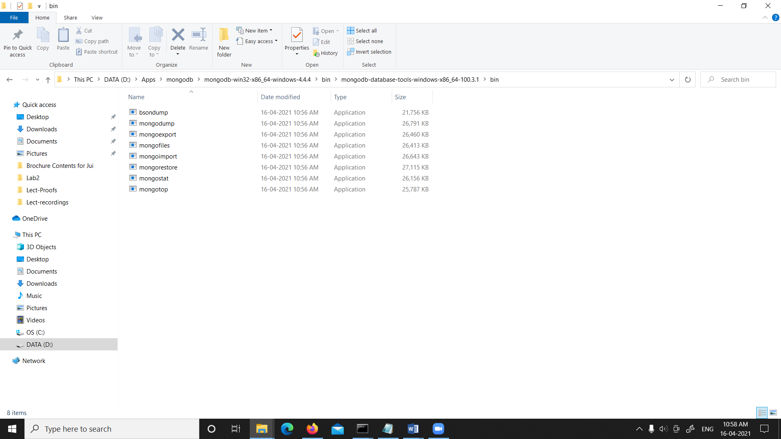

**Step 3:** Goto MongoDB bin folder and copy-paste the bin folders all .exe files into the MongoDB bin folder[C:\Program Files\MongoDB\Server\4.4\bin].

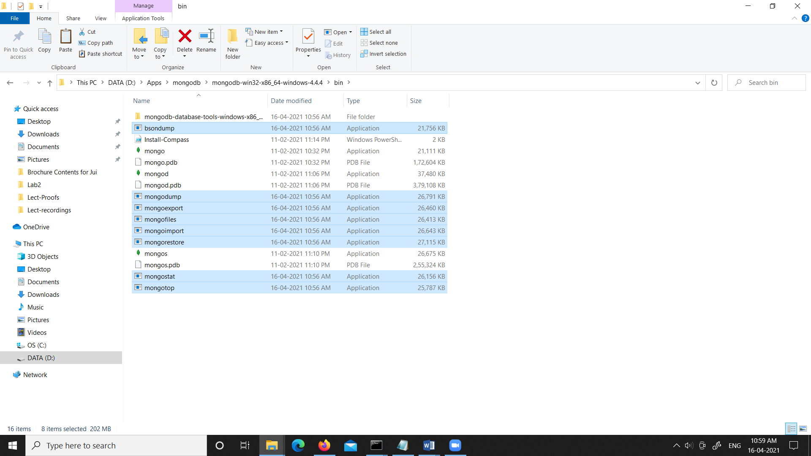

To import JSON file you need to follow the following steps:

**Step 1:** Open a command prompt and give command mongod to connect with MongoDB server and don’t close this cmd to stay connected to the server.

**Step 2:** Open another command prompt and run the mongo shell. Using the mongo command.

**Step 3:** Open one more command prompt window and direct it to bin folder[C:\Program Files\MongoDB\Server\4.4\bin] and now you are ready to import files in mongoDB database.

D:\Apps\mongodb\mongodb-win32-x86_64-windows-4.4.4\bin>mongoimport --db company --collection zip --file "D:\2020-2021\T9-BDA 2020-21\Lab2\books.json"

2021-04-16T11:17:49.398+0530 connected to: mongodb://localhost/

2021-04-16T11:17:49.823+0530 431 document(s) imported successfully. 0 document(s) failed to import.